MQLOnline

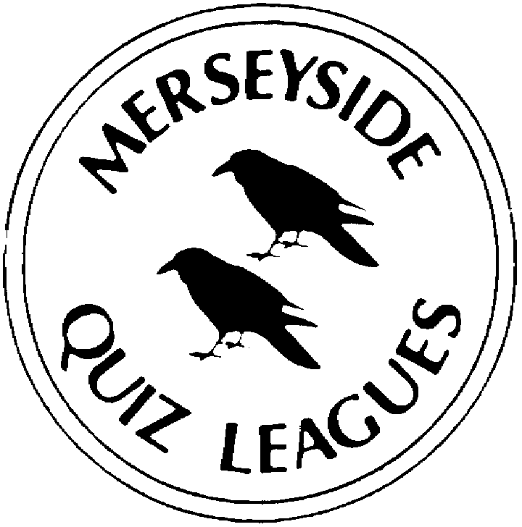

The rest of this page has been deliberately left blank
MQLOnline

Questions set by

Correct as at XXXX

Round 1
1a
1b
2a
2b
3a
3b
4a
4b

Round 2
1a
1b
2a
2b
3a
3b
4a
4b

Round 3
1a
1b
2a
2b
3a
3b
4a
4b

Round 4
1a
1b
2a
2b
3a
3b
4a
4b

Round 5
1a
1b
2a
2b
3a
3b
4a
4b

Round 6
1a
1b
2a
2b
3a
3b
4a
4b

Round 7
1a
1b
2a
2b
3a
3b
4a
4b

Round 8
1a
1b
2a
2b
3a
3b
4a
4b

Spare Questions
1
2
3
4

